**What is a Probability Distribution?**

Probability distributions allow you to represent the probability of an event using a mathematical equation. Like any mathematical equation:

* probability distributions **can be visualized** using a graph especially in 2-dimensional cases.
* probability distributions **can be worked with using algebra, linear algebra and calculus**.

These distributions make it *much* easier to understand and summarize the probability of a system whether that system be a coin flip experiment or the location of a self-driving car.

**Types of Probability Distributions**

Probability distributions are really helpful for understanding the probability of a system. Looking at the big pictures, there are two types of probability distributions:

* discrete probability distributions
* continuous probability distributions

Before we get into the details about what discrete and continuous mean, take a look at these two visualizations below. The first image shows a discrete probability distribution and the second a continuous probability distribution. What is similar and what is different about each visualization?

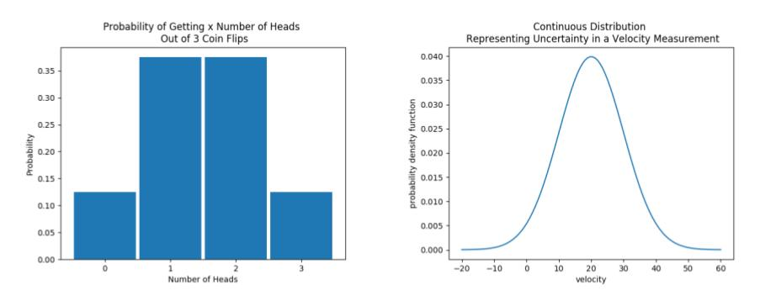

Discrete Distribution (left) and Continuous Distribution (Right)

**Discrete Variables**

As mentioned before, there are two main categories of probability distributions: discrete probability distributions and continuous probability distributions. To see the difference, let's talk about discrete variables and continuous variables.

The word **discrete** implies that a variable can only take on certain values. Usually this ends up meaning that the variable is countable like:

* Number of times a coin landed on heads
* How many times a dice landed on 1, 2, 3, 4 5 or 6



Examples of Discrete Variables

You wouldn't say that a dice landed midway between 3 and 4 like 3.4. Or that the coin landed on heads and a half. And oftentimes these discrete variables lend themselves to counting like:

* How many times did the coin land on heads?
* How many times did the dice land on five?

Of course, in a real-world experiment, the coin has some tiny tiny chance of landing on its side or the dice on an edge. But the case would still be discrete; you'd create an category like "side" or "edge" to account for those cases.

**Continuous Variables**

In contrast, a variable like temperature is continuous. Temperature can take on any decimal value like -5.6 or 100.41 degrees.

Weight, height, temperature, longitude, and latitude are continuous variables. All of these variables could be decimal values. These variables have something else in common; you'd use some sort of instrument to measure them like a thermometer, a ruler, a scale or in the case of longitude, a [**chronometer**](https://en.wikipedia.org/wiki/Longitude_by_chronometer).

Notice as well that you can't really associate counts with these variables. With a discrete variable like coins, you could count the number of times the coin landed on heads.



Examples of Continuous Variables

The probability distributions for discrete variables and continuous variables are different. In this lesson, you are going to learn the differences and similarities between the two.

**Discrete Probability Distribution**

**An Example Discrete Distribution**

We previously showed you a discrete probability distribution about flipping a fair coin three times. Let's look at this distribution again in more detail:

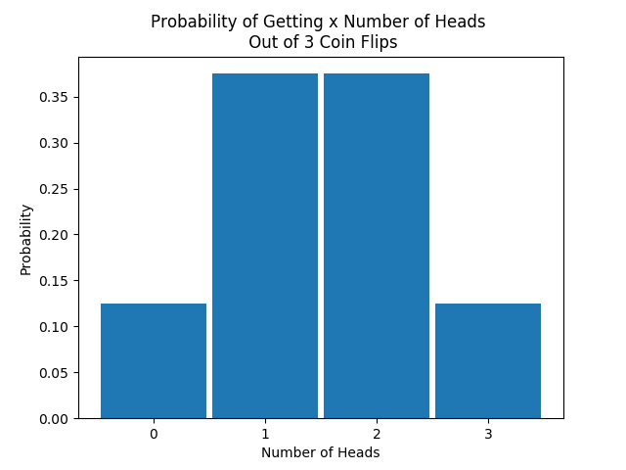

Example of a Discrete Probability Distribution Flipping a Coin 3 Times

The chart shows the probability that none of the three flips was heads, one of the three flips was heads, two of the three flips were heads, or all three flips were heads. Notice the x-axis represents the number of times that heads showed up and the y-axis represents the probability of the result.

Discrete probability distributions can also be represented in tables:

| **Heads Count** | **Probability** |
| --- | --- |
| 0 | 0.125 |
| 1 | 0.375 |
| 2 | 0.375 |
| 3 | 0.125 |

Based on the above visualization, you can see a few interesting characteristics about discrete probability distributions:

* For all values on the x-axis, the y value is greater than or equal to 0.
* For each x, the probability p(x) is equal to the y value
* The sum of all y values is 1; there's a 100% chance that something will occur.

Here is what we mean by **the sum of all y values is 1**. When flipping a coin three times, there is a 100% chance that you will either get zero heads, 1 heads, 2 heads or 3 heads (ignoring the very very small chance that the coin lands on its side).

In the next part of the lesson, you will get practice working with a discrete probability distribution.

NEXT

Here are code solutions to the previous exercises.

# Exercise: Create a List

count_data = [54, 111, 163, 222, 277, 336, 276, 220, 171, 111, 59]

# Exercise: Sum the Counts

total_count = sum(count_data)

# Exercise: Calculate a Discrete Probability Distribution

**for** i **in** range(len(count_data)):

normalized_counts.append(count_data[i] / total_count)

# Continuous Variables

In the next part of the lesson, Sebastian Thrun will introduce you to continuous variables, continuous probability distributions and the concepts behind them.

As mentioned, continuous variables can take on any any real number such as an integer or a decimal. Even a variable like the angle around a circle is continuous.

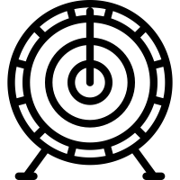

Arrow Spinning around a Wheel

The angle can take on any decimal value like 60.7423 degrees. Even though the range of legitimate values might be restricted from 0 to 360 degrees, the angle can take on any decimal between that range. Move on to the next part of the lesson to learn more.

**Continuous Probability Distributions**

In the next part of the lesson, Sebastian shows you how to visualize and make calculations with a continuous probability distribution. Before you move on, let's compare a discrete and continuous distribution again.

At the very beginning of the lesson, we showed you a discrete probability distribution next to a continuous probability distribution. Here they are again:



Discrete vs Continuous Probability Distribution

The discrete distribution is broken up into slices. Each slice represents an outcome like zero heads, one heads, two heads, or three heads.

The continuous distribution has an un-broken line across the entire x-axis range. You could have a velocity of 20 or 20.5 or -10.451.

Notice the y-axis label on the continuous distribution: "probability density function". For the discrete probability distribution, the y-axis represented the probability of an event occurring. In the continuous case, the probability density function does not represent probability directly; instead, the area underneath the density function curve represents probability.

You'll learn more about this in the next part of the lesson.

But without knowing what "probability density function" even means, you can tell that it's more likely that the velocity is around 20 and less likely that the velocity is around 0 or 40.

**Characteristics of a Continuous Distribution**

Here are a few characteristics of a continuous distribution and the probability density function. Keep these in mind as you go through the next part of the lesson.

* The y values must be greater than or equal to 0.
* The probability of a specific x value occurring is equal to 0
* The probability of an event occurring between two values of x is equal to the area under the curve between those two x values.
* The total area under the probability density function curve is equal to 1.

In practice, these rules mean that the probability that velocity equals exactly 20 is zero. For a continuous distribution, you can only calculate a probability between a range of values like 19.99 and 20.01.

Because the total area under the curve is 1, there is a 100% chance that the velocity has some value between negative infinity and positive infinity.

**Uniform Continuous Distribution**

There are many different types of continuous distributions: [**link to list of continuous probability distributions**](https://en.wikipedia.org/wiki/List_of_probability_distributions#Continuous_distributions).

But they all have the same characteristics described above. To calculate probabilities with a continuous distribution, you have to calculate the area underneath a curve. Calculating the area under a curve like in the above visualization requires calculus or a software program.

So Sebastian has chosen to use a specific continuous distribution called the **uniform continuous distribution**. The uniform continuous distribution forms a rectangle. So you can calculate the area underneath the curve simply by multiplying the base by the height.

Below is an example of a uniform continuous probability distribution. Sebastian will explain more about where this distribution comes from and how to use it.

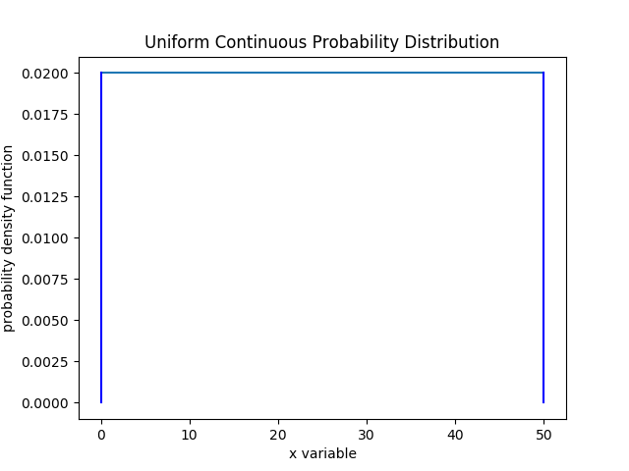

Uniform Continuous Distribution

# What Is A Density Function?

For a continuous probability distribution, the y-axis represents a probability density function.

A density function is just an equation to mathematically represent a continuous distribution. If you're familiar with calculus, the integral of the probability density function is the probability. If you're not familiar with calculus, not to worry! You do not need calculus for this section. Taking the integral is the same as calculating the area under the curve.

It's relatively easy to calculate the area underneath a uniform continuous probability distribution. These distributions look like rectangles, so the area is the base of the rectangle times the height of the rectangle.

# Piece-Wise Continuous Probability Distributions

The probability distribution you just learned about sort of looks like a discrete probability distribution. But in fact, it is still a continuous distribution. It's called a piece-wise continuous distribution. If you're unfamiliar with piecewise functions, it just means that the function is divided into parts: check out this link for [**more examples**](https://en.wikipedia.org/wiki/Piecewise).

# How To Tell If This Is Continuous Or Discrete?

Ask yourself, is my variable of interest continuous or discrete? Hour, in this case, is a continuous variable because hour can be any decimal value between 0 and 24. So this is a continuous probability distribution.

You could rephrase this problem to make it discrete. If you counted how many people were born between 1am-2am, 2am-3am, 3am-4am, etc, the problem becomes discrete. You are slicing the hour variable so that it can only take on specific values ie 1, 2, 3, 4, 5, etc.

NEXT